NAME MUHAMMD HASSAN CHISHTI

ROLL#200980

CN LAB ASSIGNMENT#2

**Q#1 Using netstat command display the following:**

1. **All “Executables” involved in creating the connections.**  By command netstat –b we can find all executables.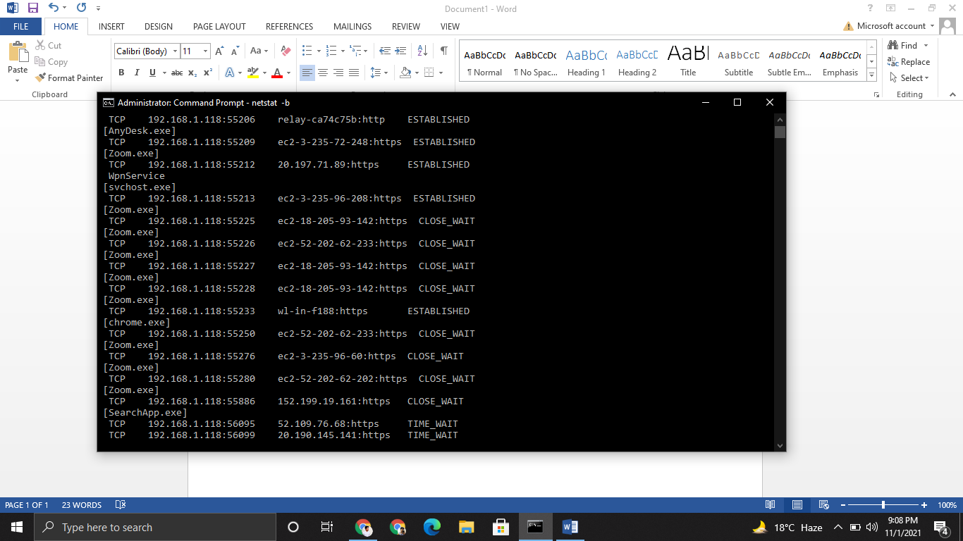
2. **The Fully Qualified Domain names**.

By command netstat –f we can find all qualified domin name.

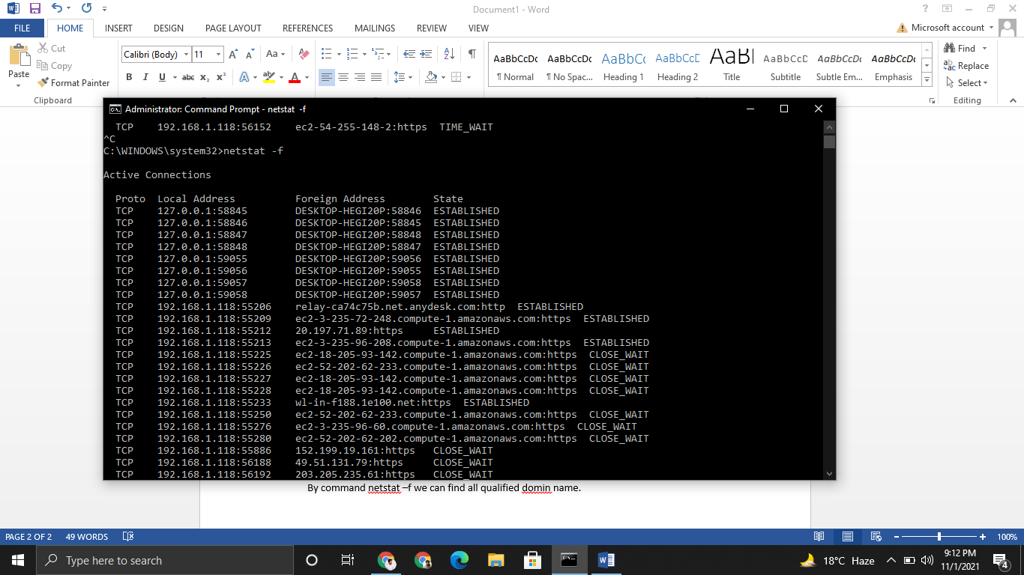

1. **Connections specifically for TCP Protocol.**

This is find by command netstat –an –p tcp

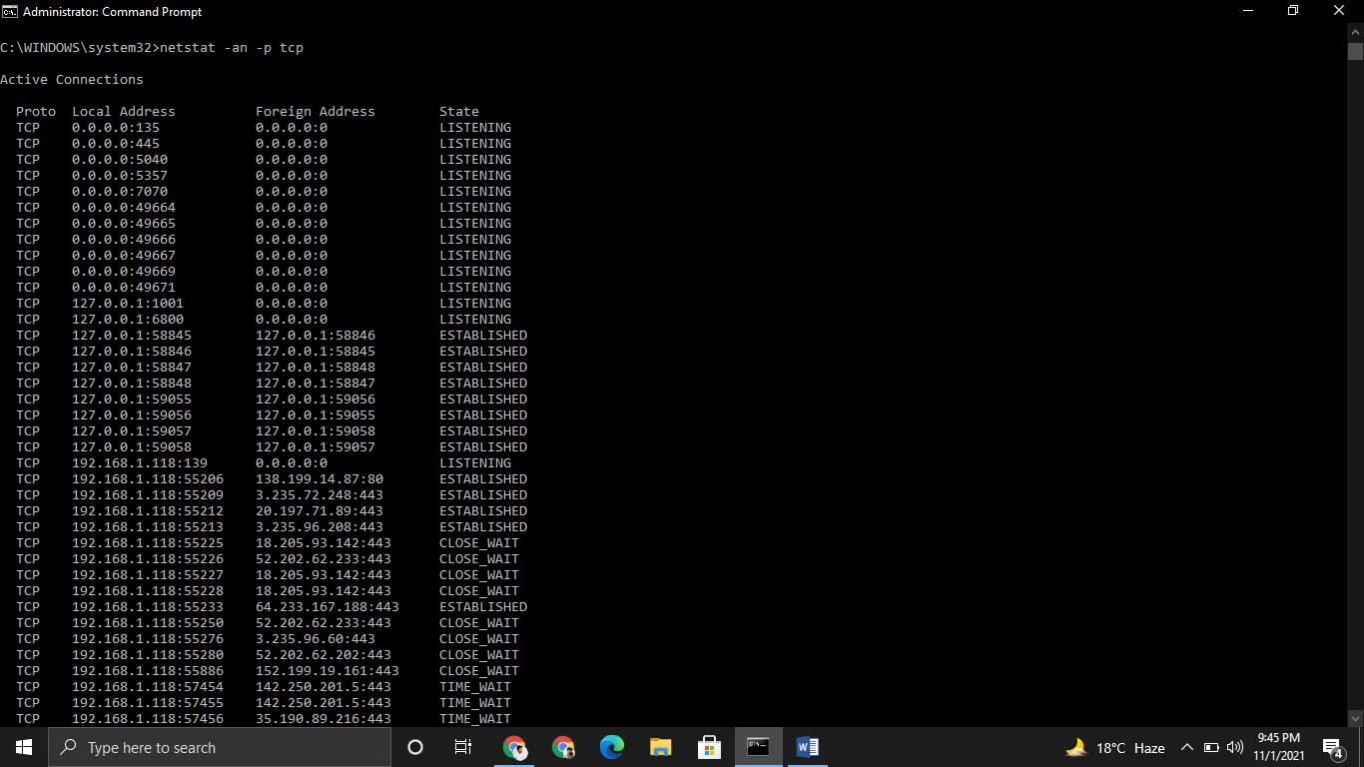

1. **Connections specifically for UDP Protocol**.

We can find this by command netstat –an –p udp

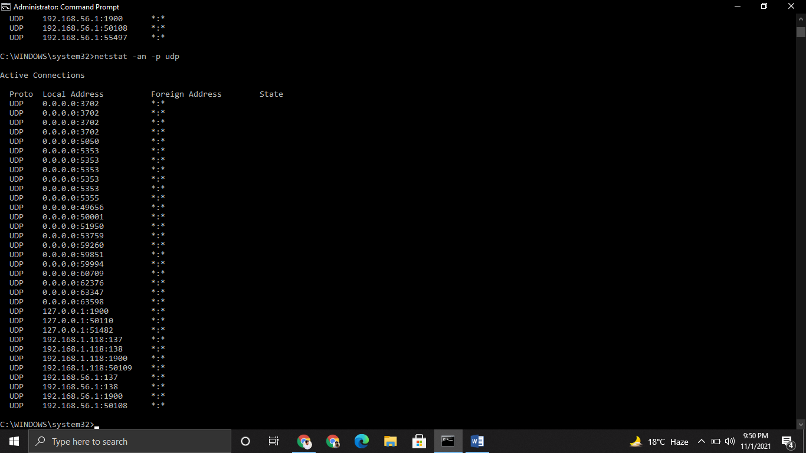

1. **The routing table.**

We can find it by netstat –r.

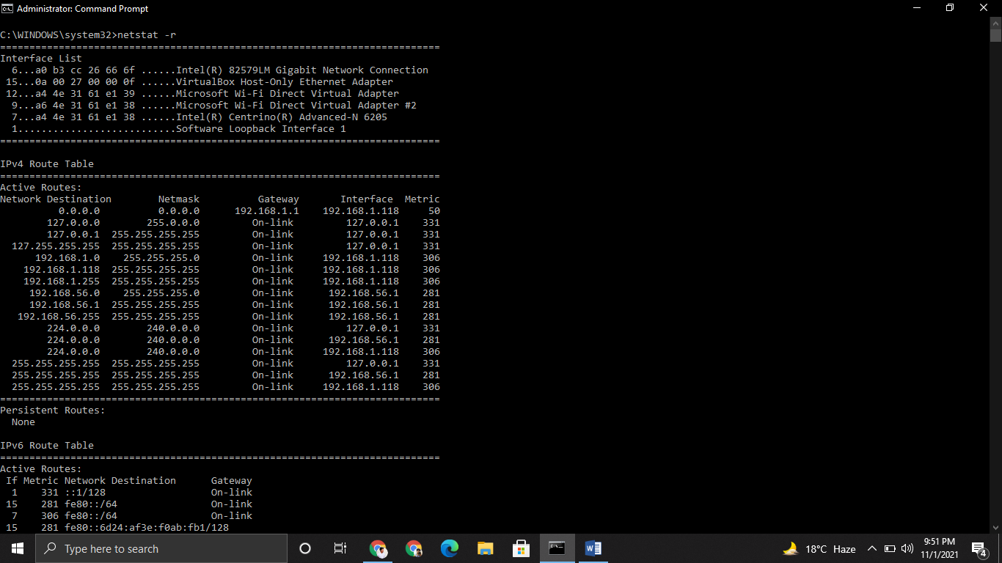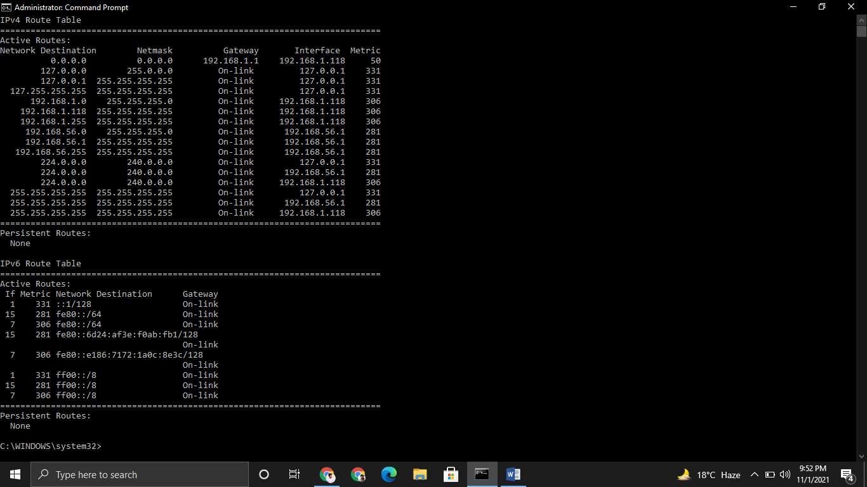

**Question 2: Using NET USER command perform the following**:

1. Create a NEW USER.

a. Name format: name{Reg}

b. Example: adnan201764

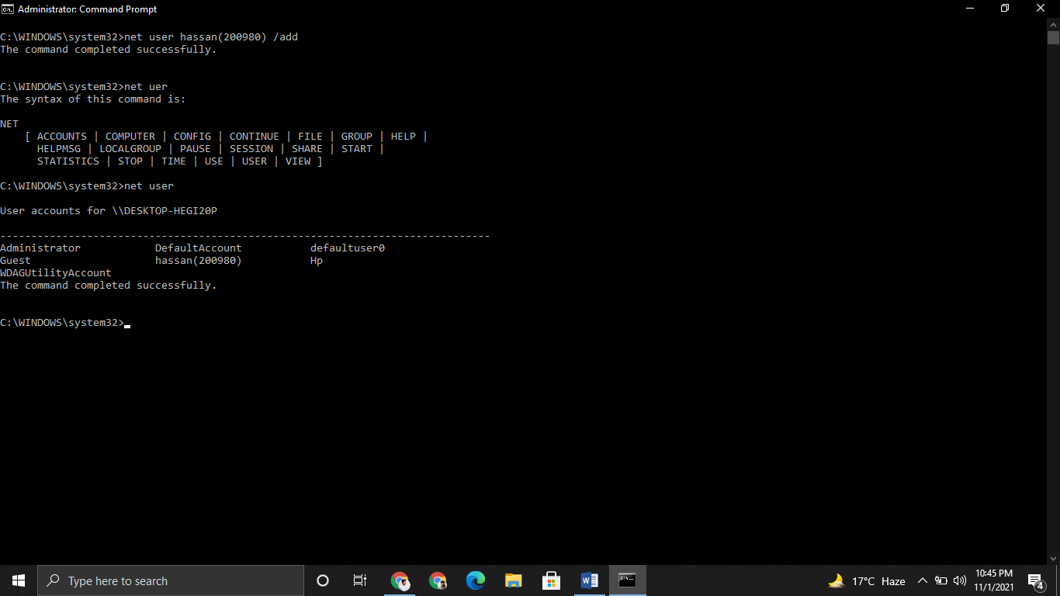

**2. Assign the time of 10AM to 3PM for Monday to Wednesday.**

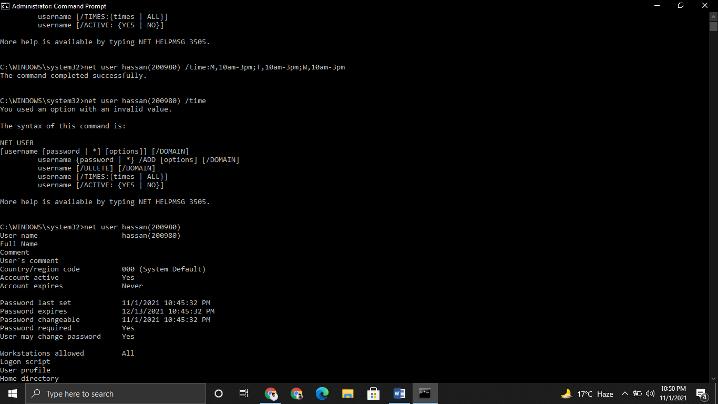

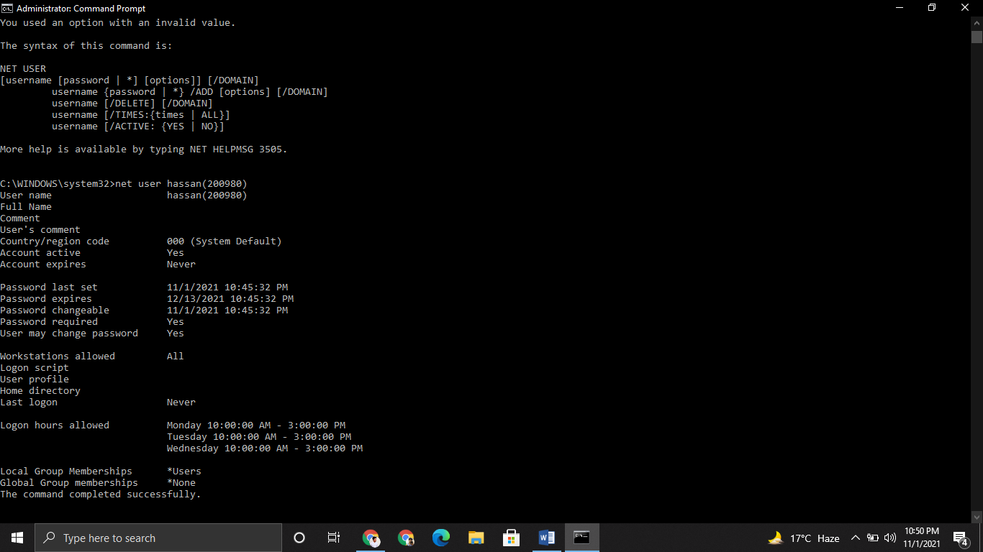

**Create New localgroup:**

**a. Name format: localgroup{Reg}**

**b. Example: localgroup201764**

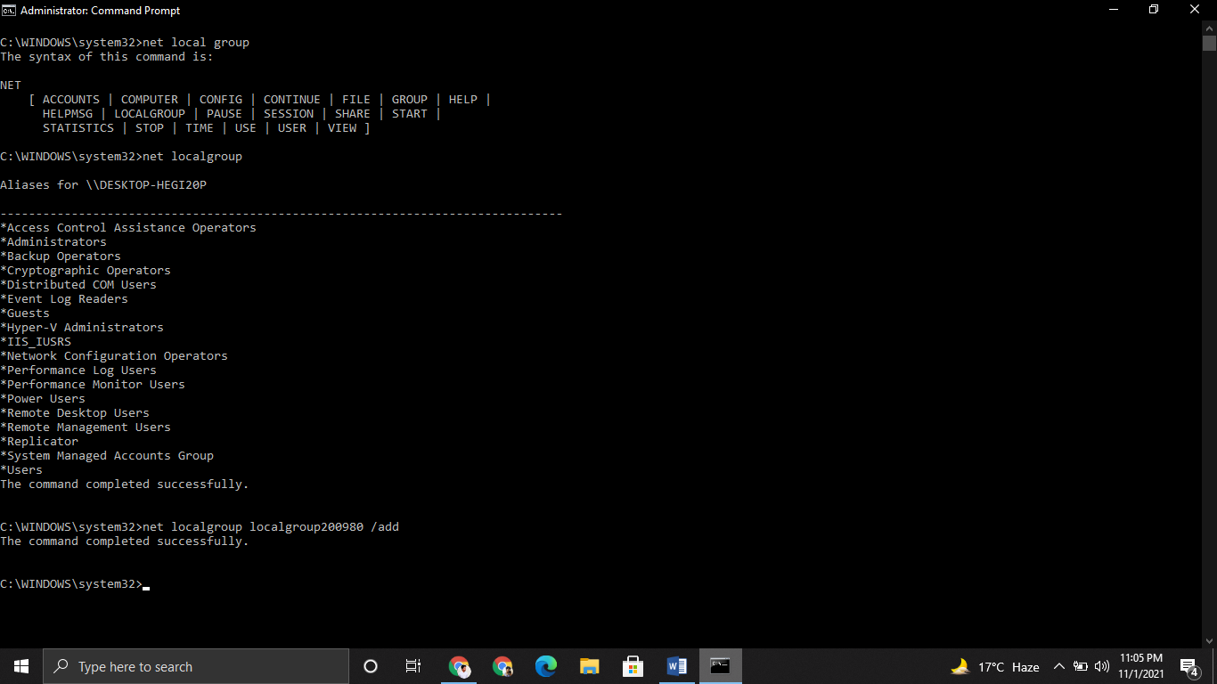

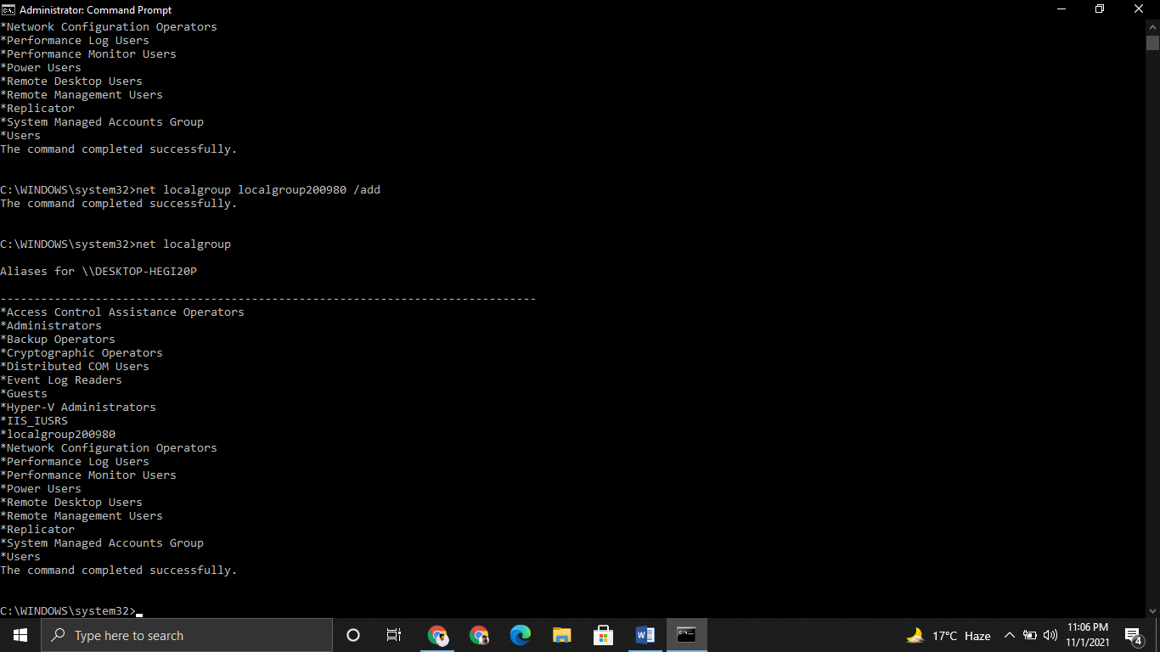

**4. Add User to the newly created localgroup.**

Command is net localgroup localgroup200980 hassan(200980) /add

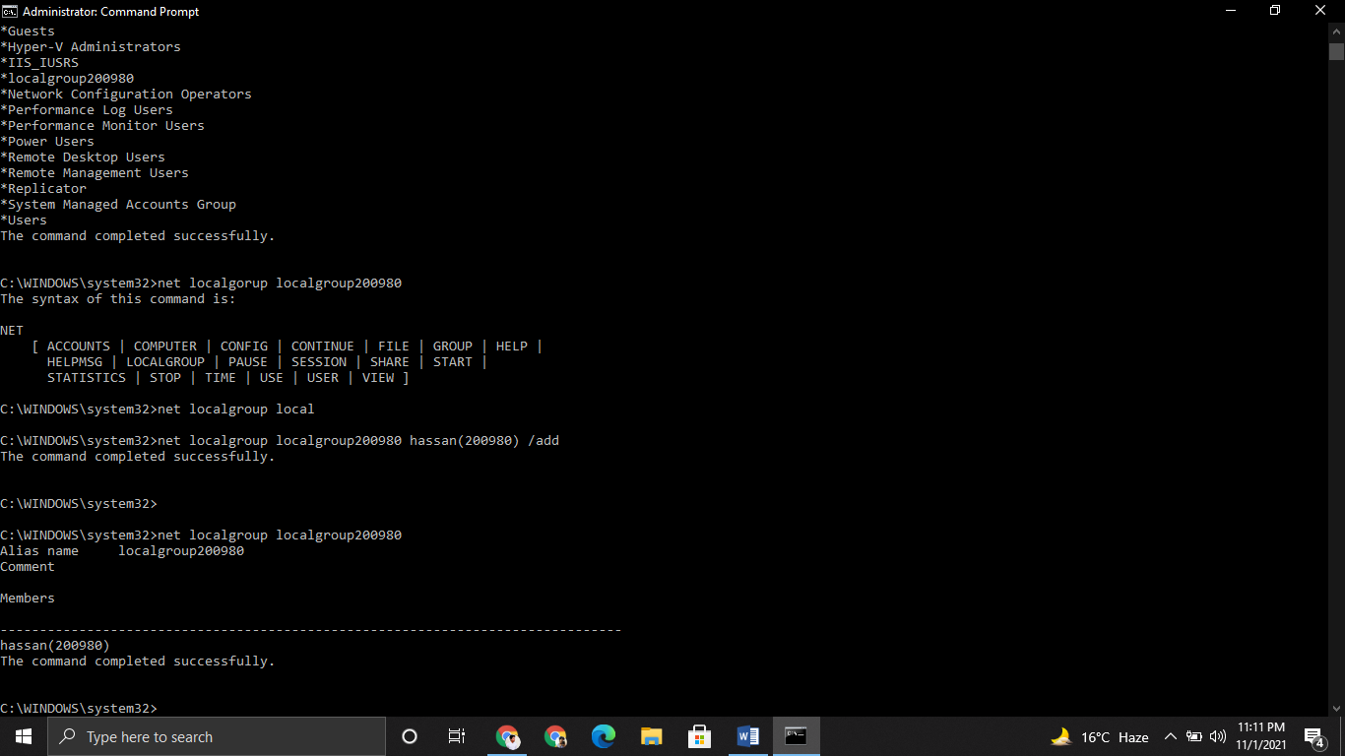

1. **Display/View the information about the User**

Command is net user hassan(200980**)**

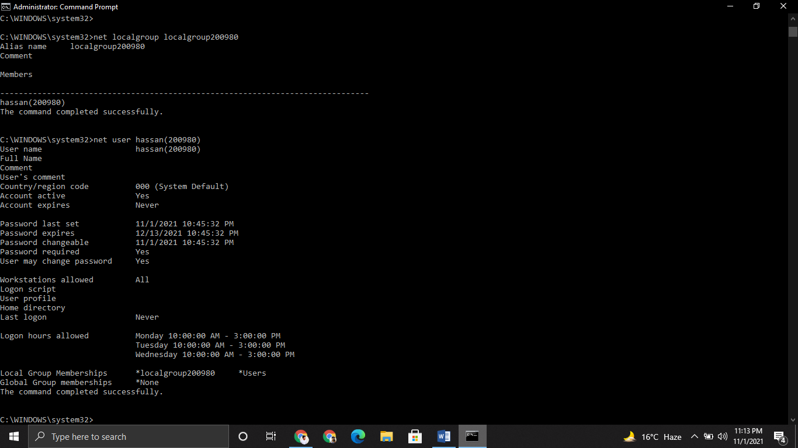

**Question 2: Using NET SHARE command perform the following:**

**Create a directory:**

**a. Name format: name{Reg}**

**b. Example: name201764**

mkdir Hassan200980

**2. Create a NEW SHARE for this directory.**

**a. Name format: sharename{Reg}**

**b. Example: sharename201764**

command is net share Hassan200980=C:\Windows /GRANT:hassan(200980),full

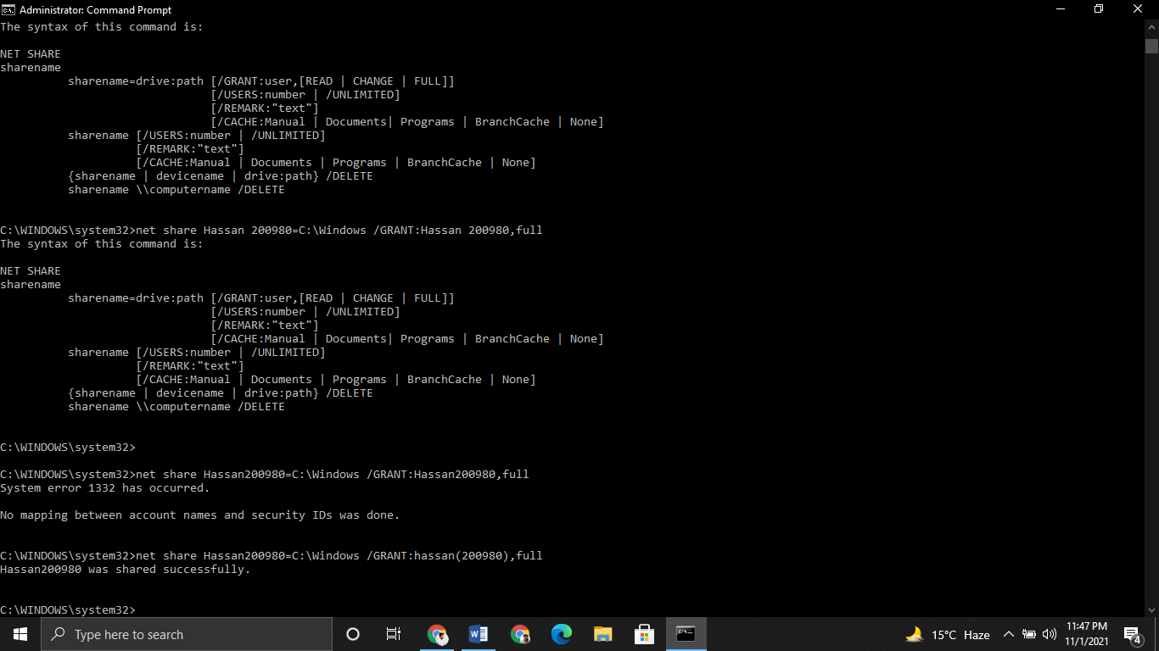

**Q#3 Grant all users (everyone) with FULL permission**

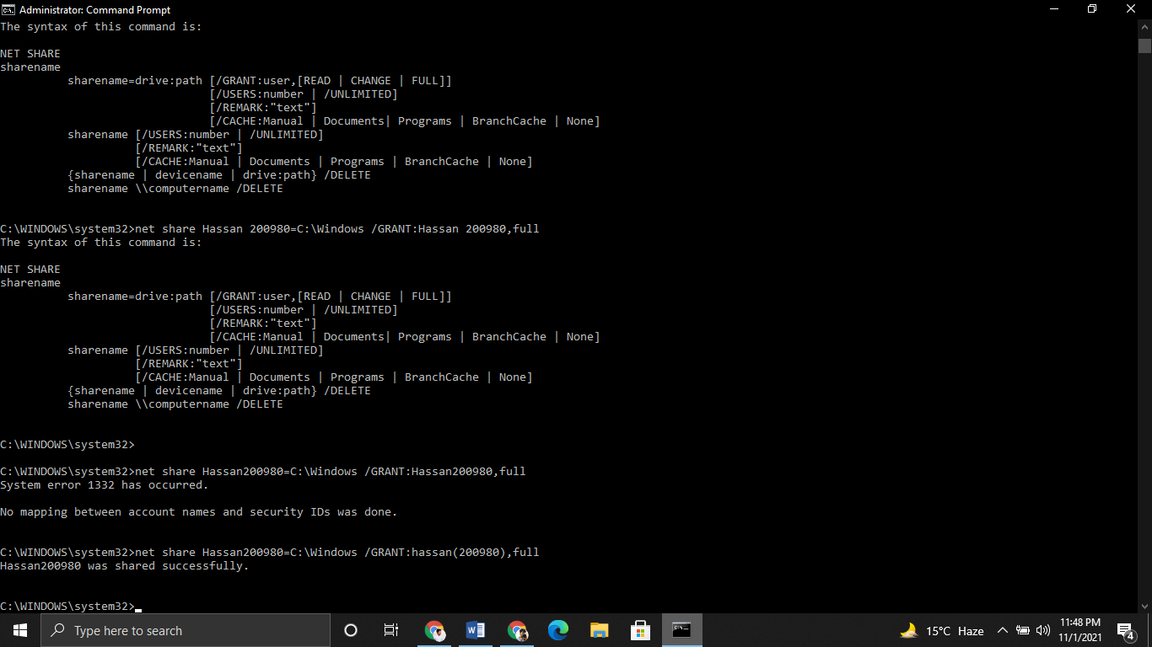

**Q#4 Set the allowed no. of users equal to the last two digits of your Reg.Number a. Example: 201764 => 64**

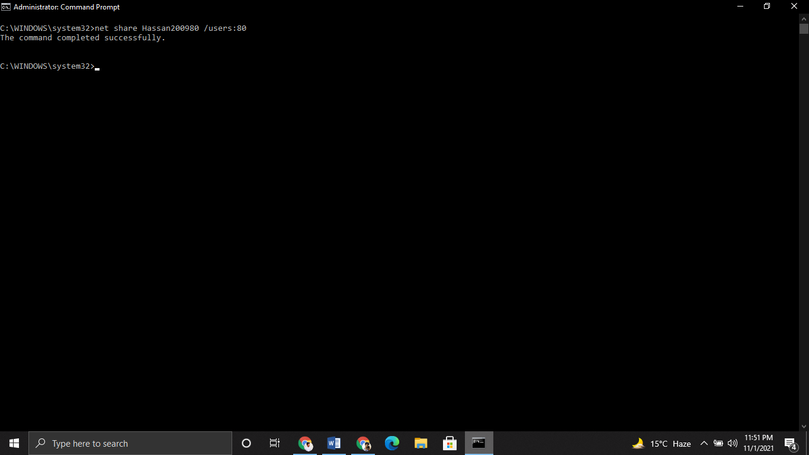

**5. Display the information for the SHARE you have created**

